Lab 8 : Access Control & Security Configuration

Table of Contents
Table of Contents 2
Introduction 3
Learning Objectives 3
Prerequisites 3
Part 1 Create a Restricted User 4
Part 2 Define Granular ACLs 6
Part 3 Test Security Boundaries 9
Test 1: Access the Allowed Topic 9
Test 2: Access the Forbidden Topic 10
Knowledge Check 11
Troubleshooting 11
Symptom: SASL authentication failed 11
Conclusion 11

Introduction
In previous labs, we granted our service accounts "Allow All" permissions just to get things working quickly. In a production environment, you must adhere to the Principle of Least Privilege.
Redpanda secures data using ACLs (Access Control Lists). ACLs define exactly which Users (Principals) can perform which Operations (Read, Write, Create) on which Resources (Topics, Consumer Groups).
In this lab, you will act as a Security Administrator. You will create a restricted service account that is only allowed to read from a specific topic, and prove that Redpanda blocks it from doing anything else.

Learning Objectives
- Create new user identities in Redpanda Cloud.
- Configure granular, resource-specific Access Control Lists (ACLs).
- Verify security policies using rpk.
- Understand TOPIC_AUTHORIZATION_FAILED errors.

Prerequisites
- A Redpanda Cloud account (Serverless tier).
- Ensure you have two topics created in your cluster: public-data and secret-data.
rpk topic create public-data secret-data

Part 1 Create a Restricted User
- Open the Redpanda Cloud UI.
- On the left sidebar, click Security.
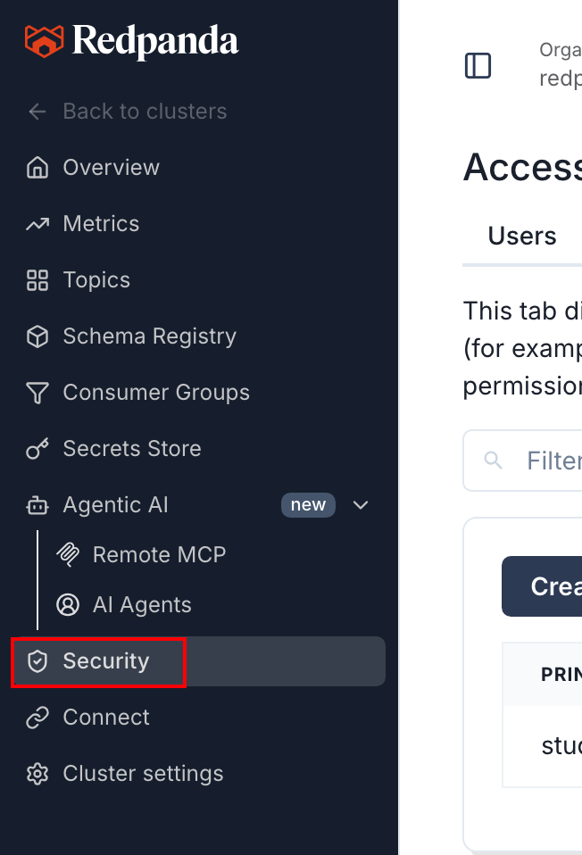
- Under the Users tab, click Create User.
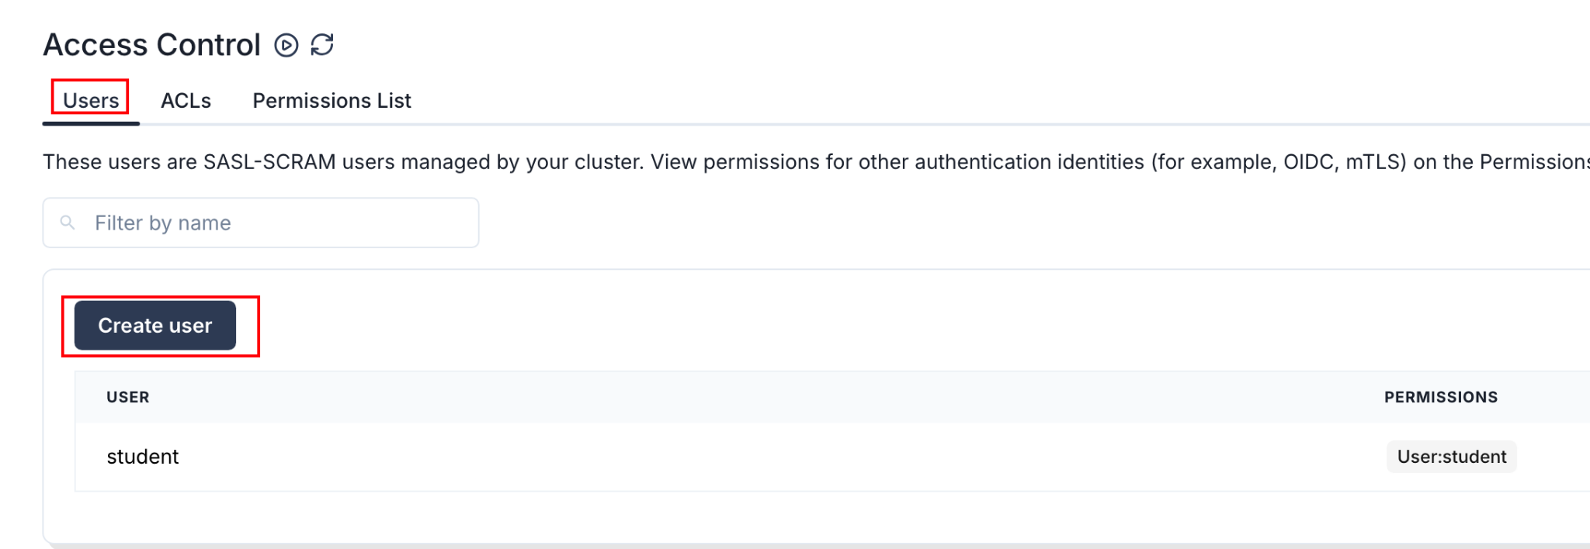
- Enter the username: analytics-service
- Type a secure password (and copy it to your clipboard).

- Click Create.

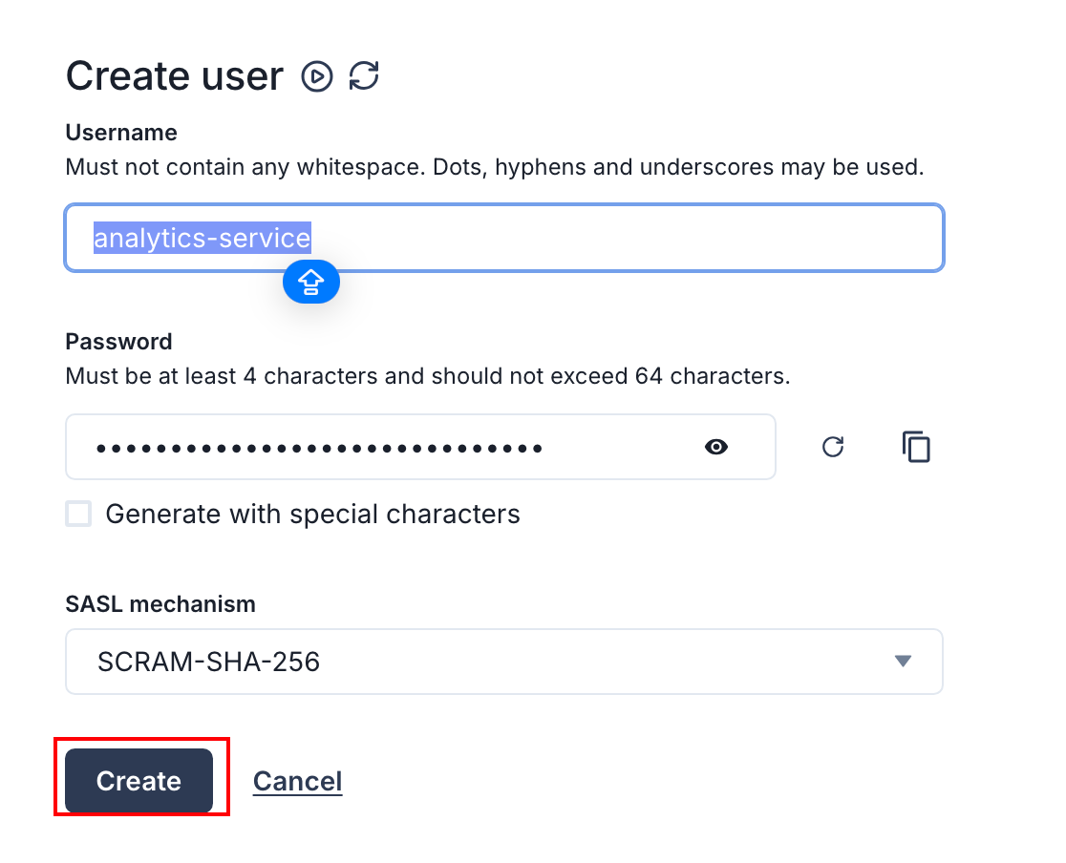

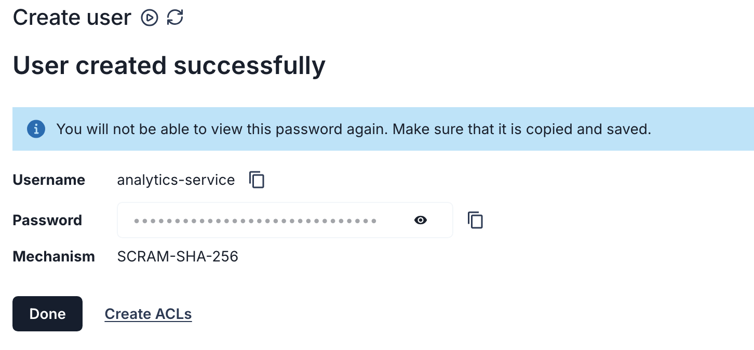
Note: At this point, analytics-service exists, but it has zero permissions. It cannot see or interact with any topics.

Part 2 Define Granular ACLs
We want to allow analytics-service to Read from public-data, but completely block it from accessing secret-data.
- In the Security menu, switch to the ACLs tab.
- Click Create ACLs.
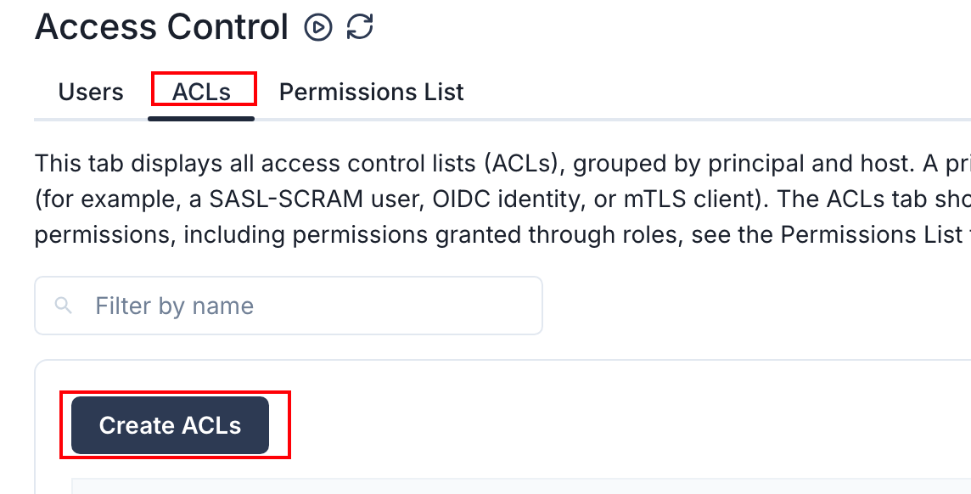
- In the User / principal field, type analytics-service.
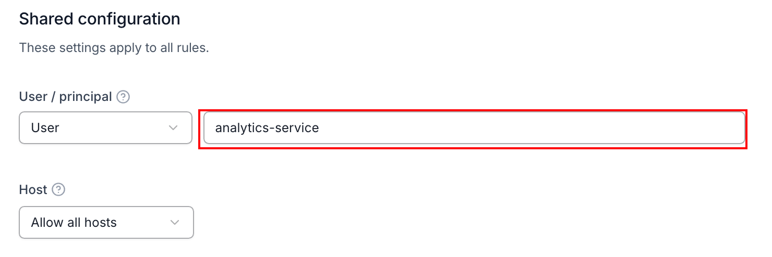
- In the Select a resource type section, click Topic.
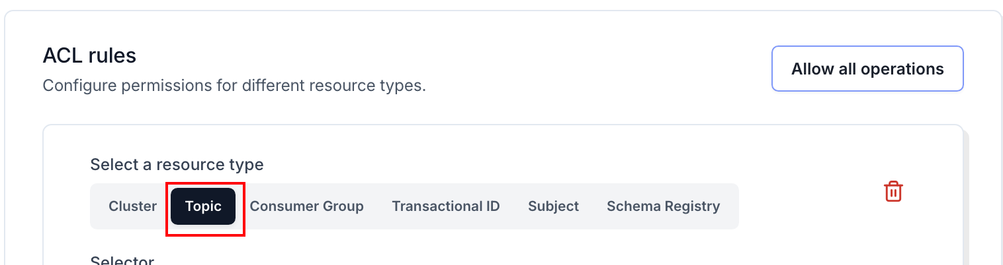

- In the Operations section, check the box for Read and Describe.
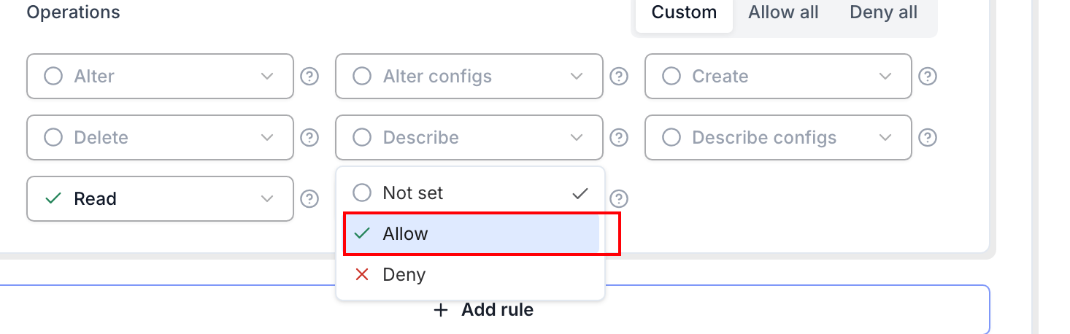
- Click Create at the right of the page.
Wait! To read a topic, a consumer also needs permission to join a Consumer Group! Let's add that.
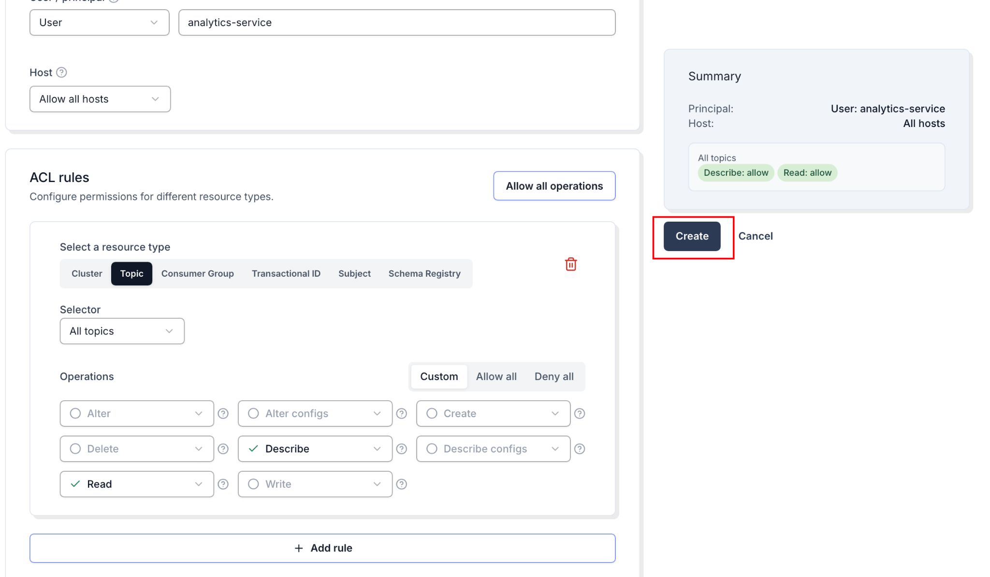
8. Click Create ACLs again.
9. User: analytics-service.
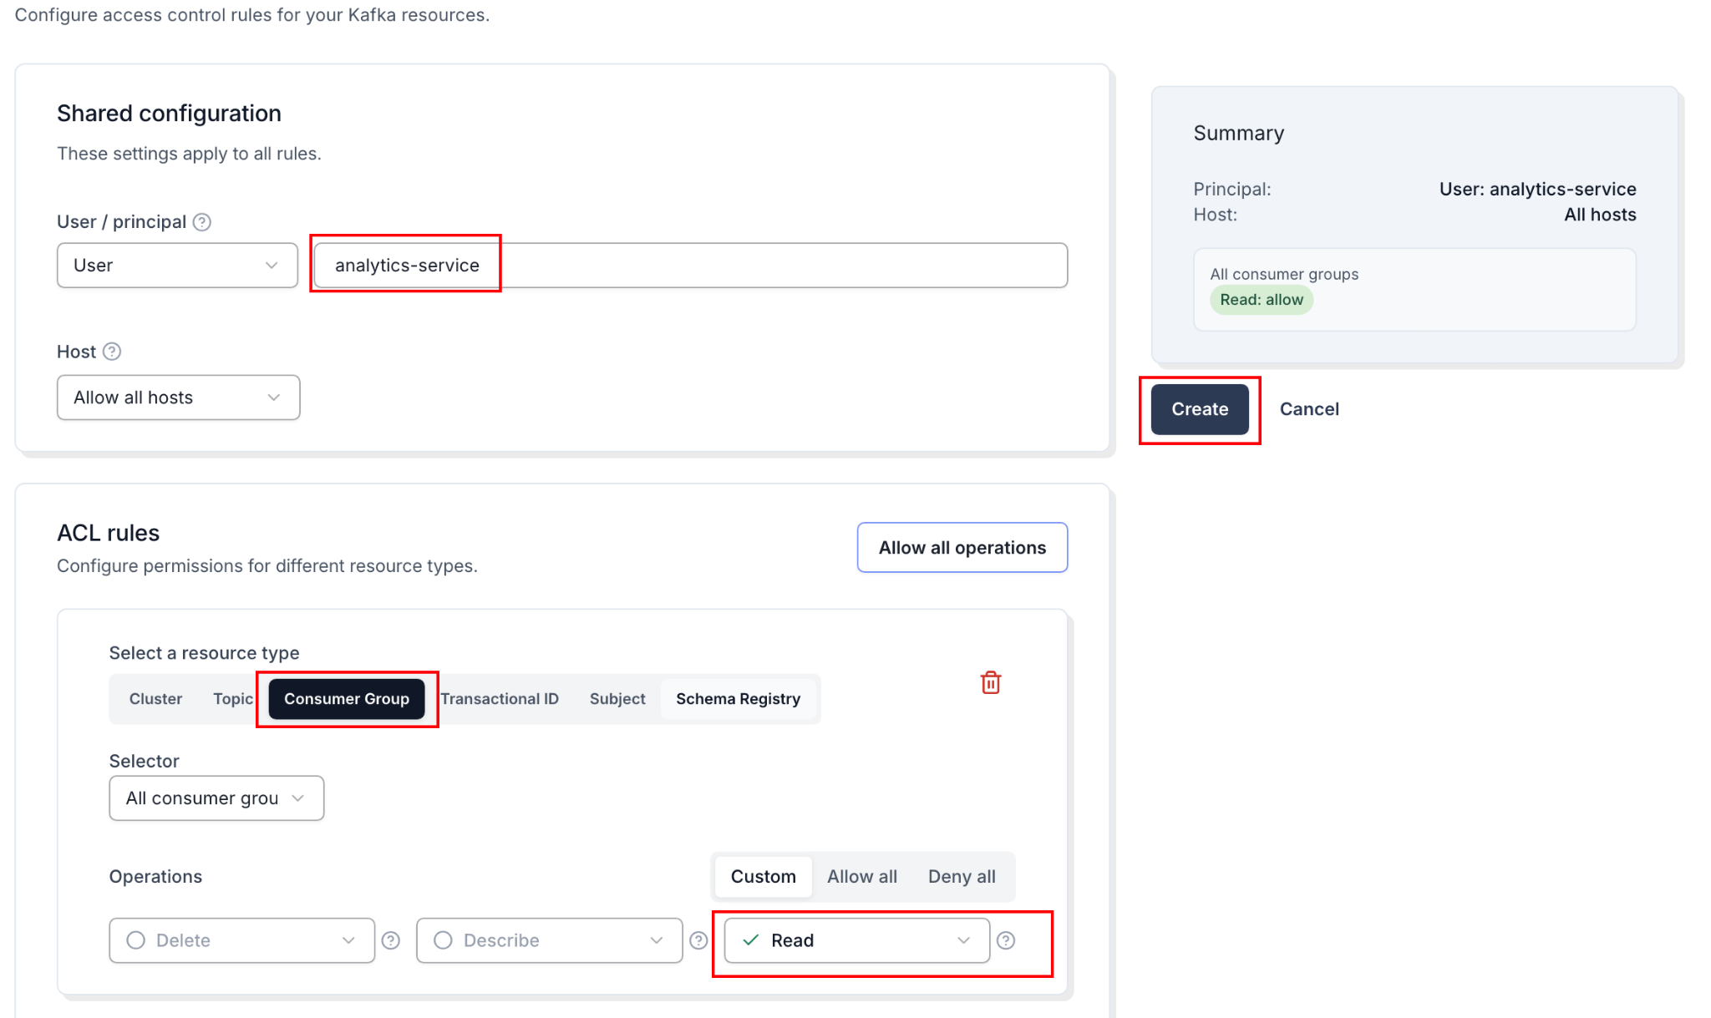
10. Resource type: Consumer Group.
12. Operations: Check Read.
13. Click Create.



Part 3 Test Security Boundaries
Let's test our security rules using the terminal.
We need to tell rpk to act as our new restricted user. We do this by passing the SASL credentials directly into the command.
(Note: Replace YOUR_BOOTSTRAP_URL and YOUR_PASSWORD below!)

Test 1: Access the Allowed Topic
Attempt to consume from the public-data topic:
rpk topic consume ui-debugging-test \
-X brokers=YOUR_BOOTSTRAP_URL:9092 \
-X tls.enabled=true \
-X sasl.mechanism=SCRAM-SHA-256 \
-X user=analytics-service \
-X pass=YOUR_PASSWORD

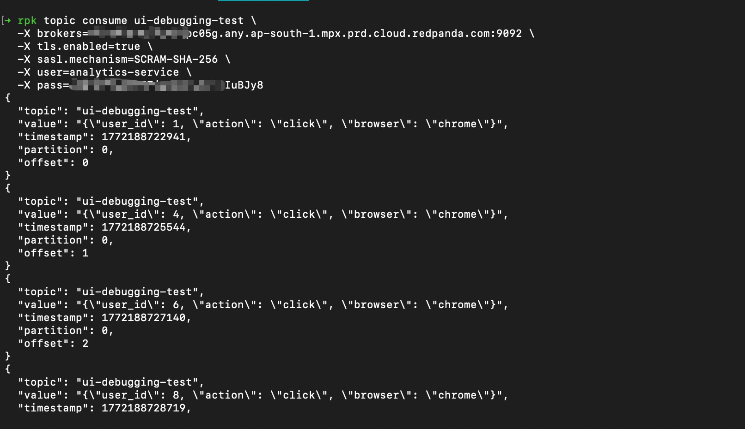
Result: It works! The command will hang and wait for messages successfully because the user is authorized. (Press Ctrl+C to stop).

Test 2: Access the Forbidden Topic
Now, try to consume from the secret-data topic using the exact same credentials:
rpk topic produce ui-debugging-test \
-X brokers=YOUR_BOOTSTRAP_URL:9092 \
-X tls.enabled=true \
-X sasl.mechanism=SCRAM-SHA-256 \
-X user=analytics-service \
-X pass=YOUR_PASSWORD

Expected Result:
unable to produce record: CLUSTER_AUTHORIZATION_FAILED: Cluster authorization failed.

Success! The security boundaries held. Redpanda explicitly blocked the user from accessing the unauthorized topic.

Knowledge Check
- What happens if a user is created but no ACLs are assigned to them?
- Answer: Redpanda defaults to "Deny All". The user can authenticate, but cannot read, write, or view any resources.
- Why did we need to grant Read access to a Consumer Group in addition to the Topic?
- Answer: Kafka/Redpanda consumer protocols require clients to coordinate offsets via a Consumer Group. If they lack permission to interact with the group, the consumption process will fail.

Troubleshooting

Symptom: SASL authentication failed
Solution: Double-check your username (analytics-service) and password. Ensure tls.enabled=true is included in your rpk command, as Serverless requires encrypted connections for authentication.

Conclusion
In this lab, you applied production-grade security practices. You learned how to restrict access using the Principle of Least Privilege by creating targeted ACLs in the Cloud UI, ensuring different services and teams can share a Redpanda cluster securely.

